WORLD
The Panama Papers: Here’s What We Know
By LIAM STACKAPRIL 4, 2016… New York Times
http://www.nytimes.com/2016/04/05/world/panama-papers-explainer.html?mwrsm=Email
panama papers explainer
From The New York Times:

The Panama Papers: Here’s What We Know

The documents name international politicians, business leaders and celebrities in a web of unseemly financial transactions.
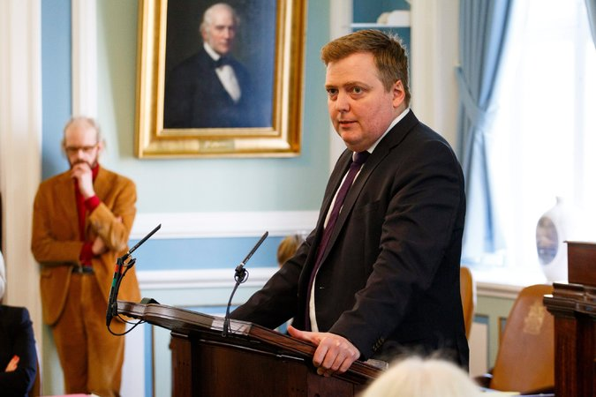

Sigmundur David Gunnlaugsson addressing the Icelandic Parliament in Reykjavik on Monday. He offered to step aside as prime minister on Tuesday.
Credit
European Pressphoto Agency
A group of global news organizations published articles based on a trove of leaked confidential documents from a law firm in Panama, Mossack Fonseca. They exposed how some of the world’s most powerful people were said to have used offshore bank accounts to conceal their wealth or avoid taxes.
Here are some significant developments:
• President Vladimir V. Putin of Russia said the leak was an American plot.
• Prime Minister David Cameron of Britain admitted that he had profited from an offshore trust.
• A federal prosecutor sought to open a criminal investigation into the business activities of President Mauricio Macri of Argentina.
• A founder of the law firm, Ramón Fonseca, told The Times that the firm was innocent of any wrongdoing.
• Relatives of President Xi Jinping of China and two other members of the Communist Party’s most powerful body were linked to offshore companies.
• The prime minister of Iceland, Sigmundur David Gunnlaugsson, stepped aside.
• The Swiss authorities raided the headquarters of the Union of European Football Associations.
• Gonzalo Delaveau Swett, the president of Transparency Chile, a branch of a global anticorruption group, stepped down.
The documents, known as the Panama Papers, named international politicians, business leaders and celebrities in a web of unseemly financial transactions, according to the articles, and raised questions about corruption in the global financial system. Many of the figures named in the leak have denied that they had broken any laws.
What are the Panama Papers?
The Panama Papers are 11.5 million documents — or 2.6 terabytes of data — provided by an unnamed source to a German newspaper, Süddeutsche Zeitung, more than one year ago. They were taken from the files of Mossack Fonseca, described as the fourth-largest offshore law firm in the world.

NEWS CLIPS: EUROPE By REUTERS 00:28
France to Blacklist Panama
Video
France to Blacklist Panama
In response to the “Panama Papers,” French finance minister Michel Sapin told his country's parliament that France will put Panama back on its blacklist of tax havens. By REUTERS on
Publish Date
April 6, 2016. Photo by Patrick Kovarik/Agence France-Presse — Getty Images. Watch in Times Video »
- Embed
- Share Tweet
Süddeutsche Zeitung shared the data with the International Consortium of Investigative Journalists, a nonprofit organization, along with reporters from over 100 news agencies around the world, including The Guardian, the McClatchy newspapers, Fusion and other outlets. The New York Times did not have access to the leaked documents.
Those media outlets are expected to publish more articles based on the Panama Papers in the coming days.
What are the most serious accusations made by the articles?
The articles said nearly 215,000 offshore shell companies and 14,153 clients were tied to Mossack Fonseca. They linked 143 politicians, their families and close associates — including 12 highly placed political leaders — to the use of tax havens to shield vast wealth.
Among those linked to involvement in offshore companies were President Macri of Argentina; President Petro O. Poroshenko of Ukraine; Mr. Gunnlaugsson, then the prime minister of Iceland; Prime Minister Nawaz Sharif of Pakistan; King Salman of Saudi Arabia; the former emir of Qatar, Hamad bin Khalifa al-Thani, and its former prime minister, Hamad bin Jassim bin Jaber al-Thani; and the Argentine soccer star Lionel Messi, according to the consortium.
The cellist Sergei Roldugin, a close friend of Mr. Putin’s, was named in the documents. The Guardian described Mr. Roldugin as being at the center of a $2 billion scheme “in which money from Russian state banks is hidden offshore.”
The president of FIFA, Gianni Infantino was linked to the scandal. The Guardian reported that the leak showed the first ties between the Union of European Football Associations (U.E.F.A.), the governing body of European soccer, and an offshore company owned by a businessman involved in the corruption scandal that lead to the ouster of Sepp Blatter as FIFA chief last year.
That link came in the form of a series of contracts between U.E.F.A. and the company, Cross Trading, that were signed by Mr. Infantino, who succeeded Mr. Blatter and served at the time as the director of legal services for U.E.F.A. On Wednesday, Swiss authorities raided the headquarters of the European soccer agency.
Juan Armando Hinojosa, who has been described as the “favorite contractor” of the Mexican president, Enrique Peña Nieto, was also mentioned in the leaked documents, which the consortium said showed that he had created “a complex offshore network” spread across nine corporate entities in New Zealand, the United Kingdom and the Netherlands to hold roughly $100 million.
Mossack Fonseca also counted among its clients close associates of President Bashar al-Assad of Syria, according to the BBC, and eight current and former members of China’s Politburo and the families of top Chinese officials. Dozens of influential donors and politicians in Britain have also been named, including Ian Cameron, the father of Prime Minister Cameron, who admitted he had earned money through an offshore trust established by his father. The older man had been a client of Mossack Fonseca with an offshore investment fund that avoided paying taxes in the United Kingdom, according to The Guardian. The elder Mr. Cameron died in 2010.
Panama Papers Leak Casts Light on a Law Firm Founded on Secrecy APRIL 6, 2016 Panama Papers Tie More of China’s Elite to Secret Accounts APRIL 6, 2016 After Panama Papers, a Raid at UEFA and New Questions for FIFA APRIL 6, 2016 Iceland’s Prime Minister Steps Down Amid Panama Papers Scandal APRIL 5, 2016 How a Cryptic Message, ‘Interested in Data?,’ Led to the Panama Papers APRIL 5, 2016
Are any Americans named in the leaked documents?
The documents indicated that 3,500 people who owned shares in offshore companies provided the Panamanian law firm with an address in the United States, but that does not mean they are American citizens. Scanned copies of at least 200 American passports were included in the trove of documents, according to McClatchy, which said that many appeared to be retirees using offshore companies to buy real estate in Latin America.

By REUTERS and THE ASSOCIATED PRESS 1:19
Officials React to Panama Papers
Video
Officials React to Panama Papers
By REUTERS and THE ASSOCIATED PRESS on
Publish Date
April 4, 2016. Photo by Brynjar Gunnasrson/Associated Press. Watch in Times Video »
Almost 3,100 companies incorporated by the law firm were linked to what McClatchy called “offshore professionals” based in the United States. But it is not clear how many United States citizens were implicated in the schemes described by the articles. So far, the documents have connected no American politicians or other influential people to Mossack Fonseca, according to McClatchy and Fusion.
One reason there may be relatively few Americans named in the documents is that it is fairly easy to form shell companies in the United States. James Henry, an economist and senior adviser to the Tax Justice Network, told Fusion that Americans “really don’t need to go to Panama.”
“Basically, we have an onshore haven industry in the U.S. that is as secretive as anywhere,” he said.
Do the Panama Papers show evidence of any crimes?
It is not clear. Several countries began investigations into the leaked data on Monday, including the United States, France, Germany, Australia, Austria, Sweden and the Netherlands.
Holding money in an offshore company is generally not illegal, although such financial arrangements can be used in illegal ways — for example, to facilitate tax evasion or money laundering.
Are there legitimate reasons for setting up foreign shell companies?
There are many valid uses of offshore shell companies for multinational corporations, joint ventures and wealthy individuals. Many countries restrict the sale of real estate to their citizens or to companies registered there. American retirees looking to purchase homes in such countries form offshore companies that buy the properties to abide by the law.
Companies establishing joint ventures in countries with weak or corrupt legal systems also create offshore companies, based in a jurisdiction like the British Virgin Islands or the Cayman Islands, that own the enterprises.
“They then get access to good courts and sophisticated financial laws,” said Jason Sharman, a professor at the Center for Governance and Public Policy at Griffith University in Brisbane, Australia. “If you can’t move the company out of a place like China, you can change the law that governs the business.”
Michel Magnan, a corporate governance professor at Concordia University in Montreal, said that for many multinationals, “setting up offshore affiliates is key for financial planning purposes, with no goal of evading taxes.”
“They can facilitate the seamless flow of funds within an organization that has extensive operations all over the world.” But, Professor Magnan added, “Their legitimate use for tax efficiency, if pushed too far, can cross over into tax avoidance.”
What has Mossack Fonseca said about the leak?
Panama’s president has vowed to cooperate with any judicial investigations. And in an interview conducted over the messaging platform WhatsApp, Mr. Fonseca, a founder of the law firm, told The Times, “At the end of this storm the sky will be blue again and people will find that the only crime is the hacking.”
In a previous statement to The Guardian, the Panamanian law firm defended its practices and appeared to threaten the news agency with legal action.
The firm said that it was “legal and common for companies to establish commercial entities in different jurisdictions for a variety of legitimate reasons” and maintained that it had “always complied with international protocols” to the best of its ability to ensure that companies it incorporated were not being used for illegal or illicit purposes.
But it said the news agency had obtained “unauthorized access to proprietary documents and information taken from our company.”
“Using information/documentation unlawfully obtained is a crime, and we will not hesitate to pursue all available criminal and civil remedies,” its spokesman, Carlos Sousa, wrote.
What has been the fallout from the leak so far?
One of the first major repercussions occurred in Iceland, where Prime Minister Gunnlaugsson asked his deputy to take over his position, after thousands of people protested outside Parliament calling for him to resign.
Mr. Gunnlaugsson’s name appeared in the leaked documents in connection with an offshore company he established in the British Virgin Islands with a partner, whom he later married. The leak suggested that he had sold his shares of the company to his wife for $1 just before a new law took effect that would have required him to report his ownership of it as a conflict of interest.
Mr. Gunnlaugsson maintained that he had not concealed his assets or avoided paying tax.
In Chile, the president of the country’s branch of Transparency International, an anti-corruption group, quit after the Panama Papers linked him to at least five offshore companies.
The organization said in a statement that though its president, Mr. Delaveau, was not accused of illegal activities, it was “deeply troubled by what has happened.”
Many of the other figures named in the leaks have denied any wrongdoing. A spokesman for the Kremlin, Dmitri Peskov, called the Panama Papers a case of “Putinophobia” and a plot to destabilize the country.
The spokesman’s wife was also named in the documents as the owner of an offshore company.
Towers of Secrecy
Leaked documents known as the Panama Papers show world leaders using secretive shell companies. The Times found in an investigation last year that shell companies are often used to move money into U.S. real estate.
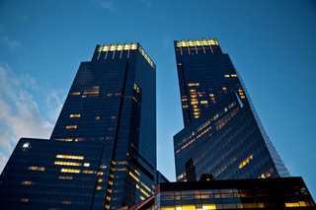

Steven Erlanger and Bryant Rousseau contributed reporting.

