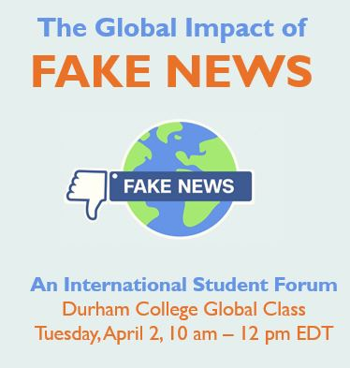
“GLOBAL IMPACT OF FAKE NEWS”
International Student Forum
Tuesday, April 2, 2019
10 – 11:30 am
AGENDA

9:45 – 10:10 Technical testing and classroom prep
10:10 – 10:15 Introduction & hellos – Val Lapp, Sanjay Bharthur, Johana Bejeranos
10:15 – 11:10 HOW DOES FAKE NEWS IMPACT OUR COMMUNITIES?
Participants share answers to these questions in discussion.
- How is it started and spread?
- What form does it take?
- Who is mostly responsible and what is their motivation?
- What is the impact?
- What steps are being taken to stop its spread?
11:10 – 11:20 ONE FINAL QUESTION (Time permitting)
What can we do ourselves to stop the spread of fake news in our own communities?
11:20 – 11:30 – WRAP

